|  |  |  |
| --- | --- | --- |
| Product Catalogue | Battery connector |  |
| Connector type | Battery base |  |
| Applicable battery specifications | CR1220 |  |
| Operating temperature range | - |  |

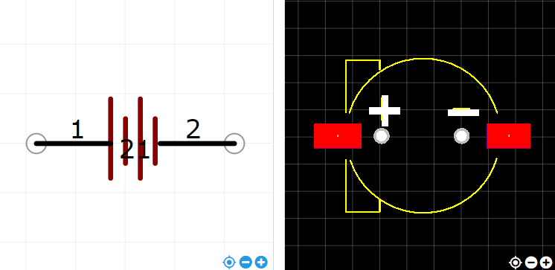

<https://item.szlcsc.com/71476.html>